Nischal Shrestha
Coventry University Student ID Number: 17103446
B.Sc. (Hons.) Computing, Softwarica College of IT and E-commerce, Coventry University
ST4005CEM Database System
Giriraj Rawat

- Create a table called library with the following columns:
Book_id, title, author, price, gener must include Science, History and Biography.

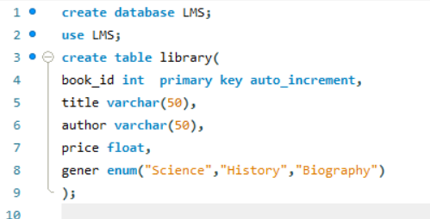
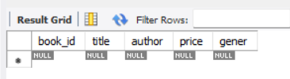

- Insert the following 10 records into the library table:
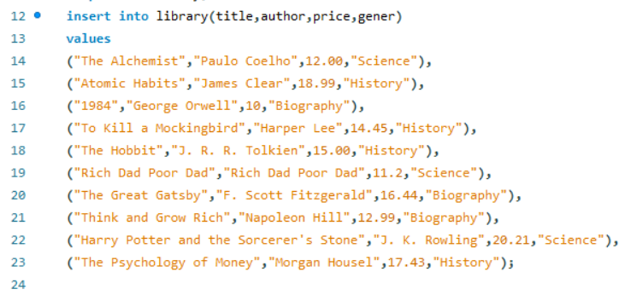
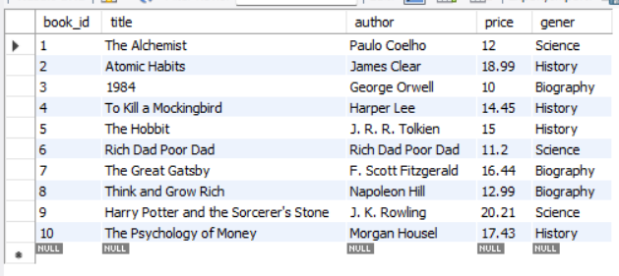

- Retrieve all books from the library table.


- Retrieve only title and author columns

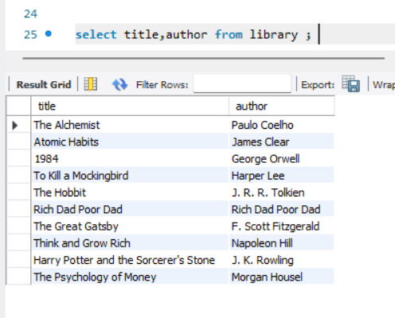

- Retrieve books where genre is 'Science'
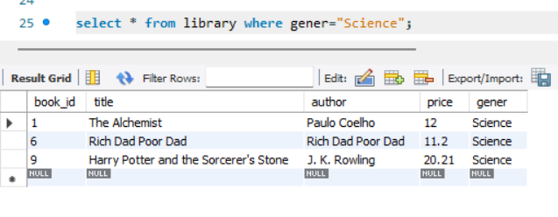

- Update the price of 'Harry Potter' to 699.99.
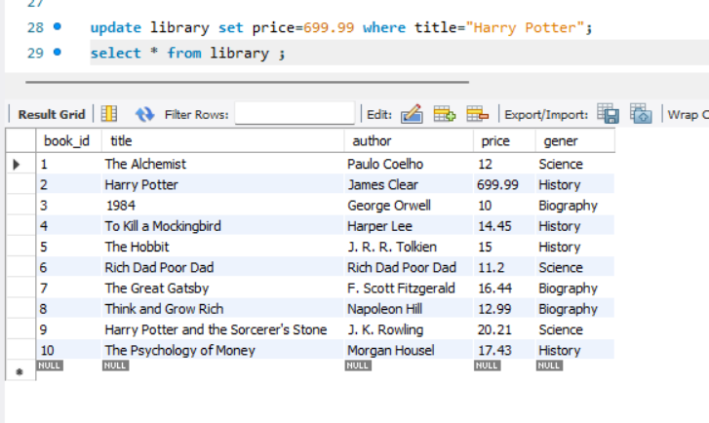

- Update the author of book_id 3 to 'Ram kc'.
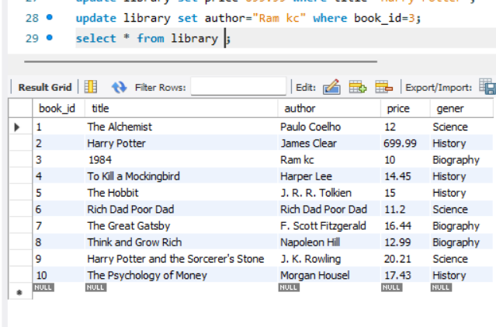
- Delete the book where book id = 4.
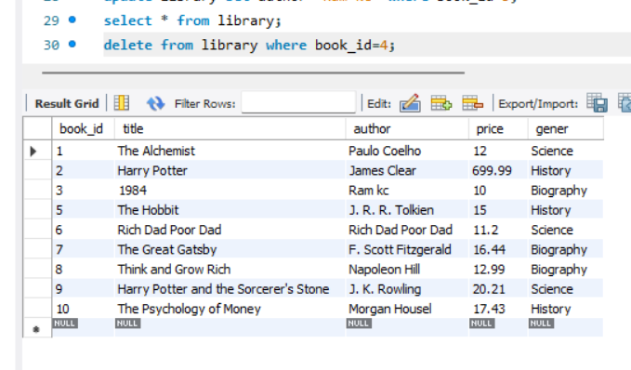

- Delete all books where price < 600.
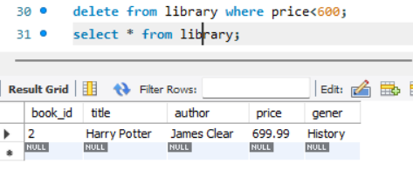

- Create a table called employees with:
emp_id, name not null, email unique, phone unique, department default value
'general'.
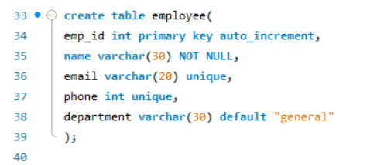

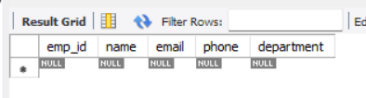

- Create a table called products with:
product_id, product_name, stock default value must be 0, price, must be greater than 0, Status available, out of stock and default value must be available.

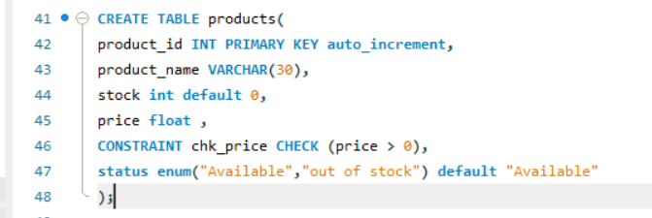
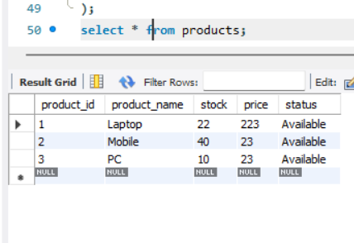

- Query to delete all records of products table but keep the table structure.
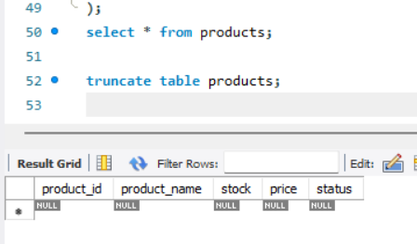

- Add a new column salary (DECIMAL 10,2) to the table.
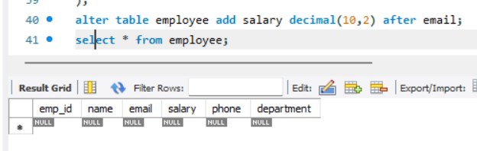

- Rename the column phone to mobile_number
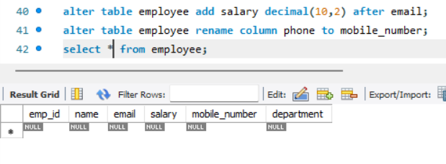

- Rename the table employee to staff.
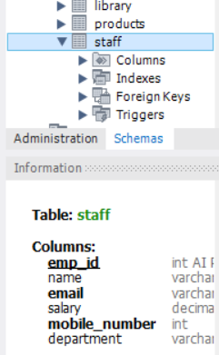

- Retrieve all books where genre is either 'Biography' or 'Science'.
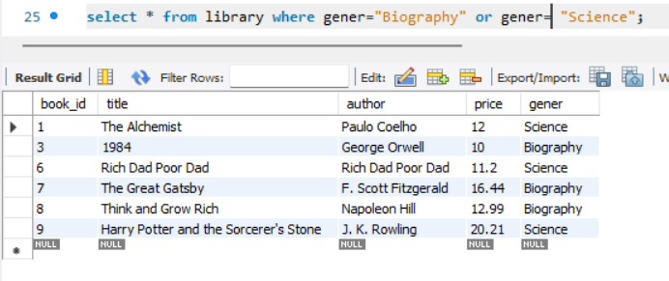

- Retrieve all books where book_id is IN (1, 3, 5)

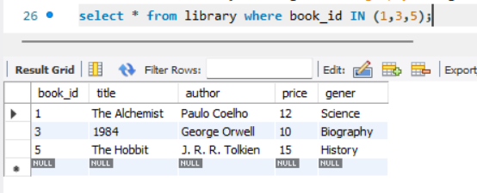

- Retrieve all books where price is between 500 and 800

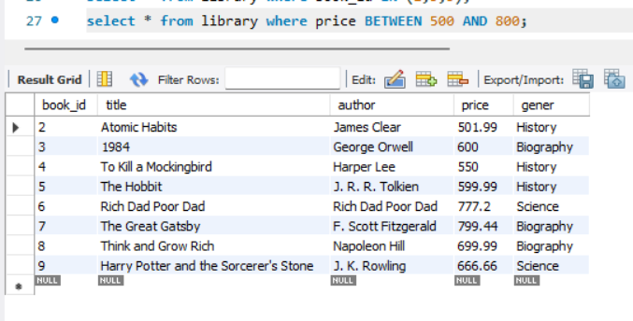

- Retrieve all orders placed between '2024-01-01' and '2024-12-31'

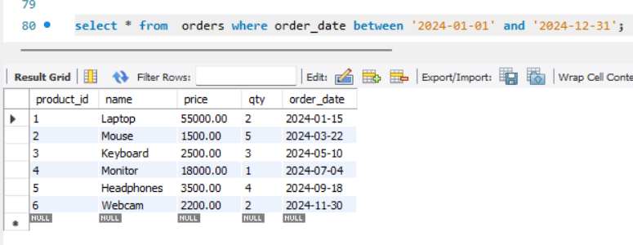

- Write a query using CASE to:
If department is 'IT' increase salary by 20%
If department is 'HR' increase salary by 15%
If department is 'Finance' increase salary by 10%
All others increase salary by 5%
